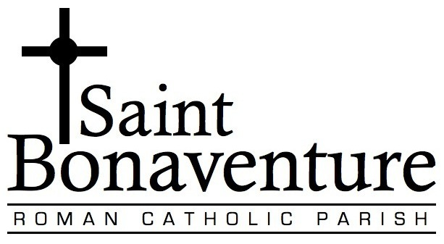

Program intended for children in grades 2+ who have been

baptized Catholic or have made a Profession of Faith.

***Registration Information***

CHILD’S Full Name _____________________________________________ Date of Birth: __________________

Day/Month/Year

Child’s Preferred Name: (if applicable) ________________________________

Child’s School: ________________________________ Grade: _____________

Date of Birth: _______________________________ Gender: Male Female

Mother’s Name: ______________________________________Cell Phone: __________________________

Father’s Name: _______________________________________Cell Phone: __________________________

Address: __________________________________________________ Postal Code: __________________

Home Phone: _________________________________________________

Email: ________________________________________________________ (for communication via email)

***Baptism Information* A copy of your child’s baptism certificate must accompany this form**

Child Baptized in the Catholic Faith? Yes

At St. Bonaventure Church? **(no certificate required)**

Other Church? (below)

Name of Church: _________________________________________ Date of Baptism : ____________________

City and Province of Church: ___________________________________Country: ______________________

**OR**

MADE A Profession of Faith (baptized in another faith but received into the Catholic Church)

At St. Bonaventure? **(no certificate required)** If not, which parish? ______________________________

Parent Signature: ____________________________________________ Date: ___________________________

******

Volunteers are needed to teach the children while the parents are learning in their session. If you are a second or third time Sacrament Preparation parent or you are a Catholic School teacher, we would love you to volunteer to teach/help with the children’s sessions. All material is provided and you will be set up with volunteer screening and training. Lesson plans and material will also be provided.

Yes I can teach/help

No, I am not able to help at this time

**Sacrament of First Reconciliation & First Communion**

**REGISTRATION FORM**